Ryan Bleile && Ankit Adlakha

COMP 155 Lab Exercise

Dec. 3rd

1/2)

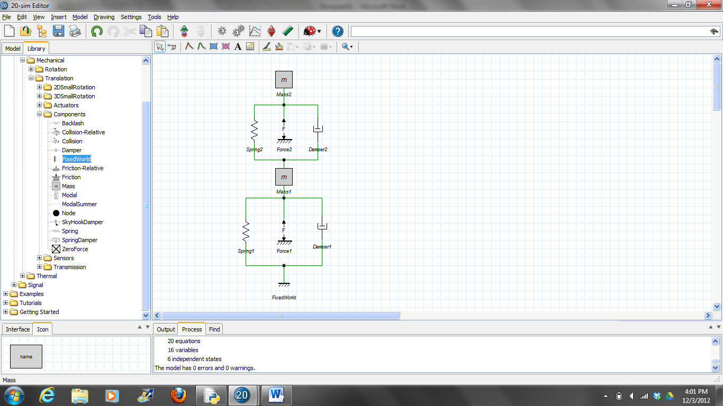

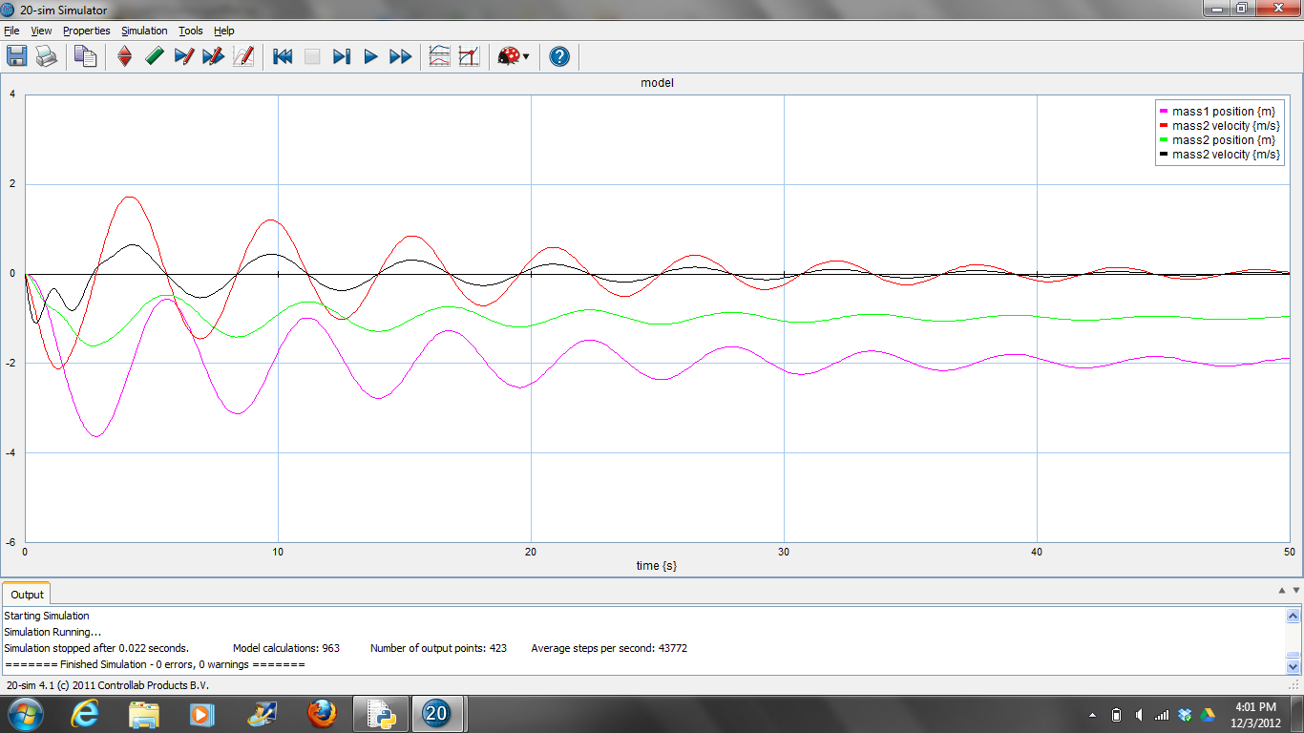

3)

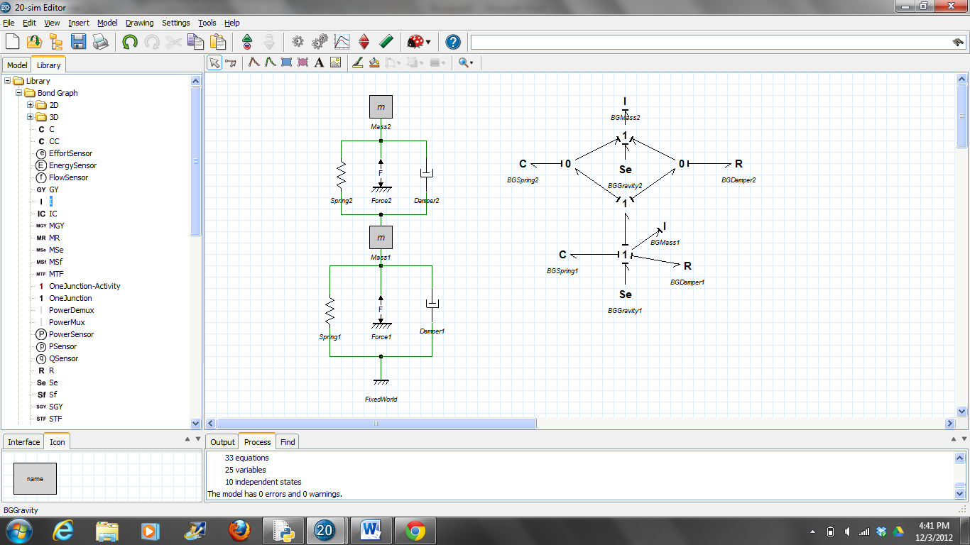

Can’t figure out how to plot state/spring2 – state/spring1 variable

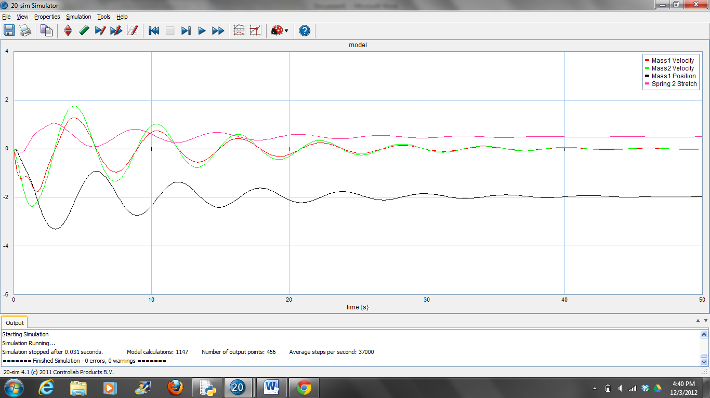

4)

Scenario 1:

Hypothesis:

System will reach equilibrium and the equilibrium positions of the masses should be the same.

Observation:

Hypothesis is correct

plots:

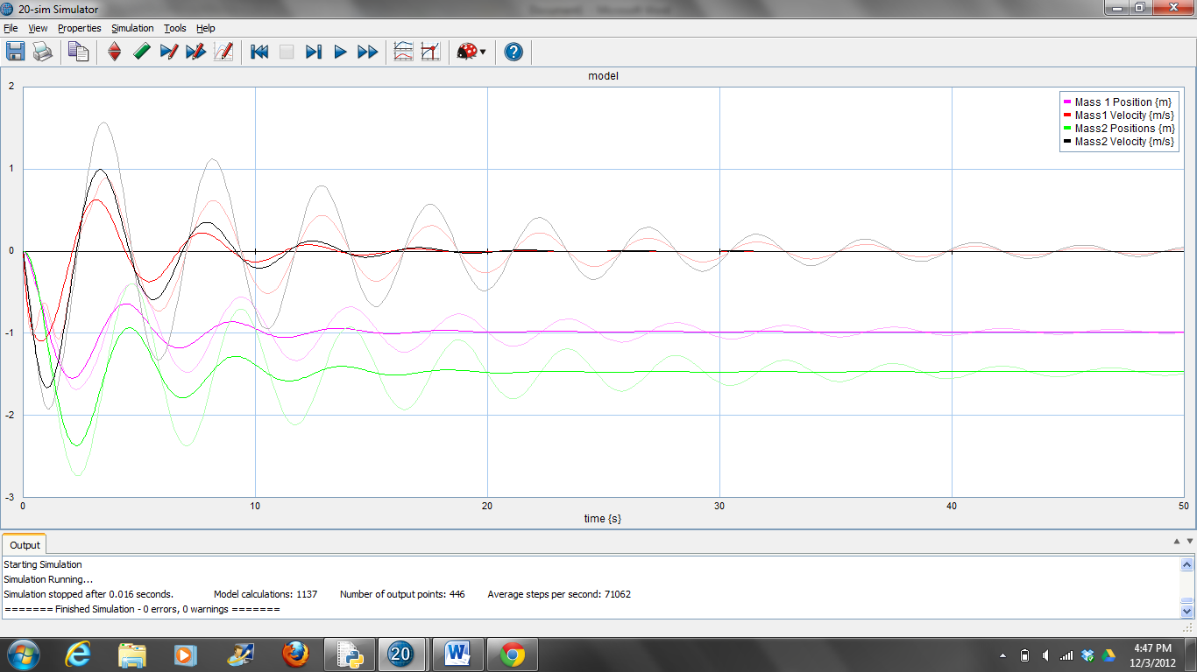

Scenario 2:

Hypothesis:

Time it takes to reach equilibrium will be longer

Equilibrium positions remain unchanged

Observation:

Hypothesis is correct

Plots

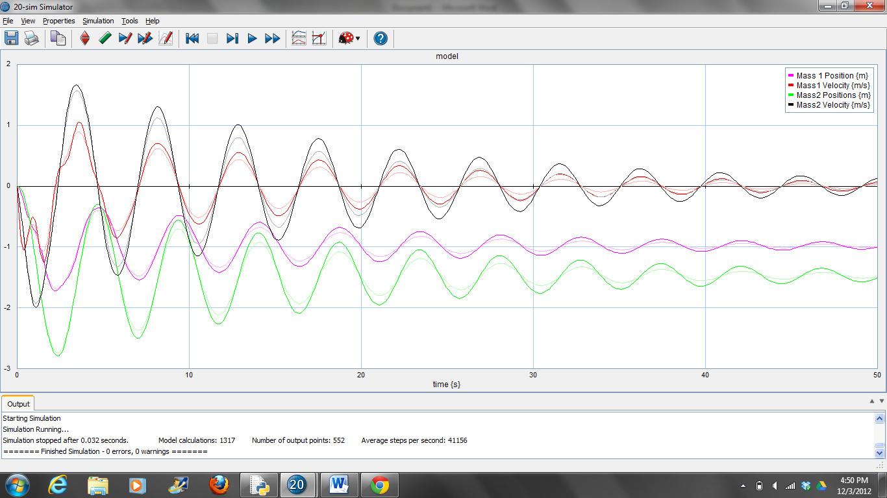

Scenario 3:

Hypothesis:

Time it takes to reach equilibrium will not change

Equilibrium position will change

Observation:

Hypothesis incorrect, Equilibrium time and position changed

Plots:

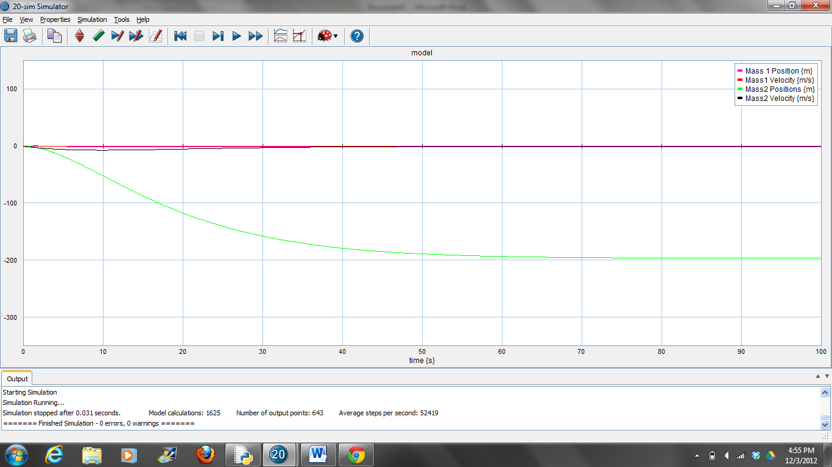

Scenario 4:

Hypothesis:

Spring1 will not move hardly at all behavior of system will appear from spring 2

Observation:

Hypothesis correct. Spring1 returns to equilibrium very quickly and then is steady

Plot:

